**Task 2 – TCP attacks**

By OR BEN ABA(323092692)

***1)Syn flooding attack***

1.a) In this task, I am going to flood the half-connections queue for TCP of some server, and no one could not get a connection with the server because it will be too busy. I am going to test the countermeasure to this DOS which is SYN-COOKIES. I will use netwox 76 to send a lot syn packets to the server and after few seconds the client try to connect and we'll see what happen. In the second time, I will generate the countermeasure and see what happen in this time, is something will be changed?

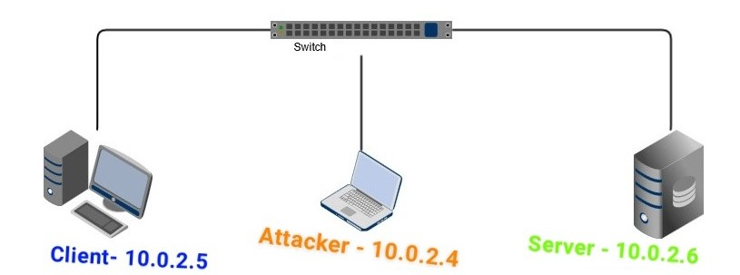

1.b)The size of the queue of half-opened TCP connections in the server:

**SERVER**

Is 128.

Executing the attack while the TCP syn cookies are off:

*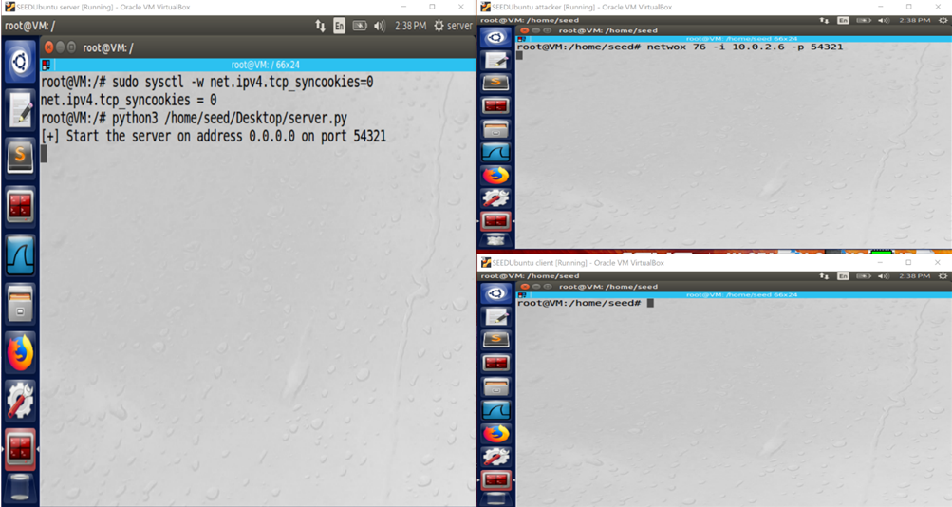Note that the server starts running and* ***only*** *after it does, the attacker floods the server.*

**CLIENT**

**ATTACKER**

**SERVER**

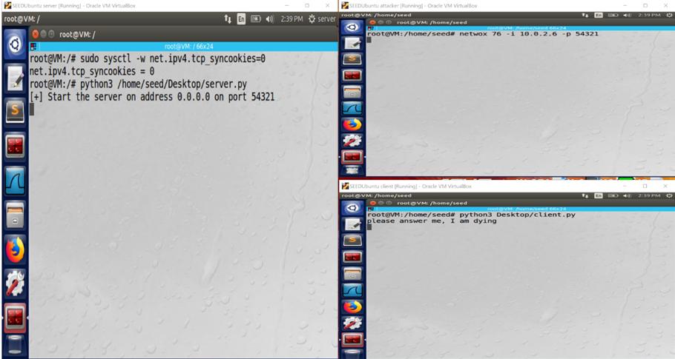The client tries to run its script to get the echo service from the server, but he can't cause the TCP queue for half connections in the server is flooded.

**CLIENT**

**ATTACKER**

**SERVER**

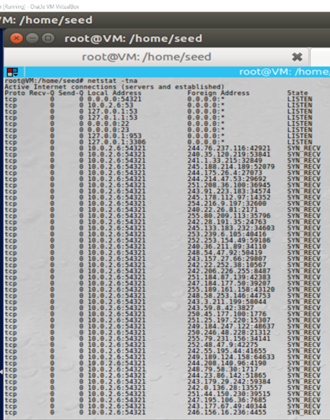More reliable proof for my claim(running netstat -tna to get the queue status in the server), and as you can easily see it is super-flooded.

**SERVER**

Now, turning on the TCP syn cookies:

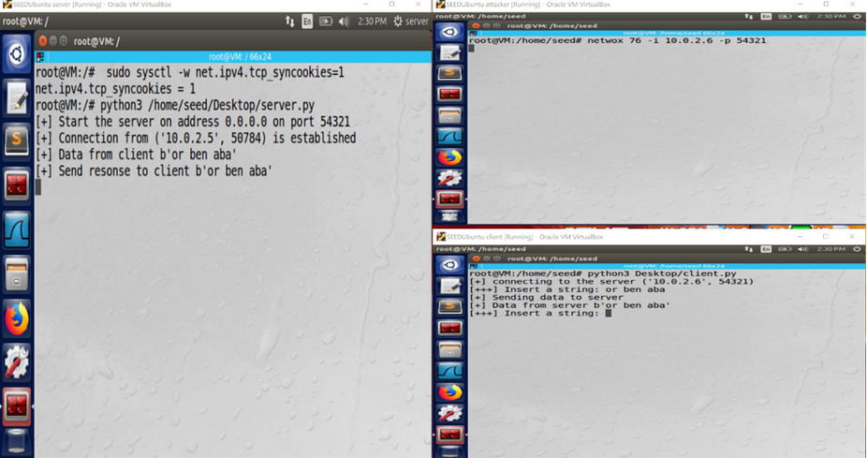The client connects to the echo server although the attacker simultaneously "floods" the server.

**CLIENT**

**ATTACKER**

**SERVER**

1.c) To sum up, I succeed the task. As a proof for our attack, it is enough to show that the half-connections queue for TCP is full so that is make sense that the client cannot handshake the server. I discovered that it is very easy to DOS servers using this attack. I have also learned to write socket scripts in python to both client and server. In addition, I learned what countermeasures are used to that sort of attack. The practice is very resemble to the theory, in theory I know that the goal is to DOS the server by that I will open a lot of connections with it and a legitimate client couldn't open another connection, this was the same in the experience. The one problem which drive me crazy was the SYN-COOKIES, in the beginning I have tried to perform the attack but accidentally forgot to turn the cookies off, it tool me time but the problem was solved.

***2)TCP reset attack***

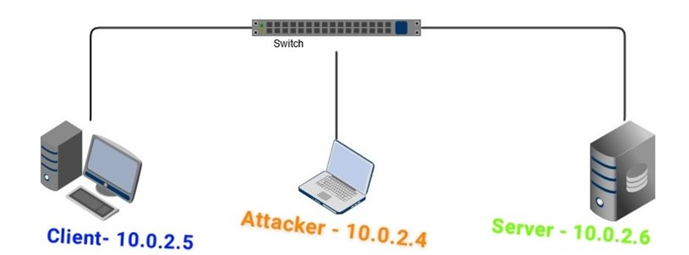2.a) In this task I am going to disconnect a TCP connection. To do this I will spoof a packet which has a signature of TCP segment that is recognized in my LAN, while the RST flag in this segment is on. I will guess(smartly) the sequence number of this connection until I wll see that the connection will be broken. To get the signature, I wll use wireshark and for the spoofed packets I use scapy one time and the other time in netwox. Note that it does not matter what protocol is stands in the application layer. The server will think that the client send him a TCP RST packet and then the connection will be closed.

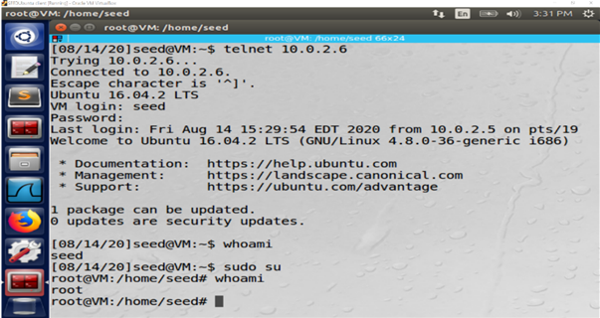2.b)The client connected to the server through TELNET.

**CLIENT**

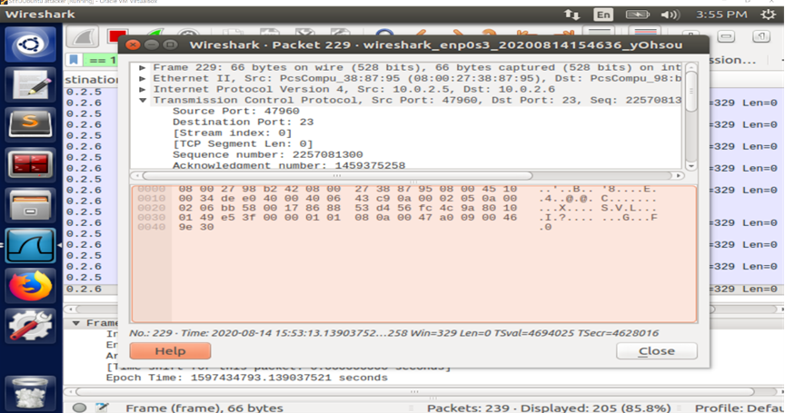The client in the meantime, send the commands over the TELNET protocol. After couple of minutes since the connection was established, the attacker is sniffing packets sniffing the last packet of the relevant connection using WireShark.

**ATTACKER**

Using netwox(40) in order to spoofing a packet which is sent(not really) from the server to the client and resets this connection;

*The sequence number is chosen to be the next sequence number according to the spoofed packet.*

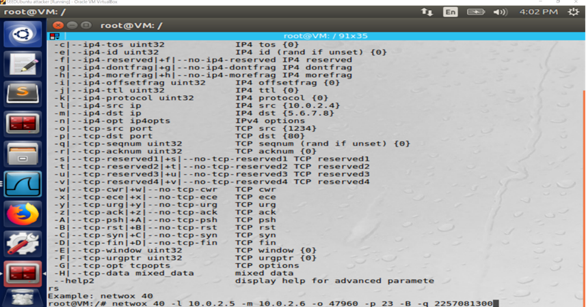

**ATTACKER**

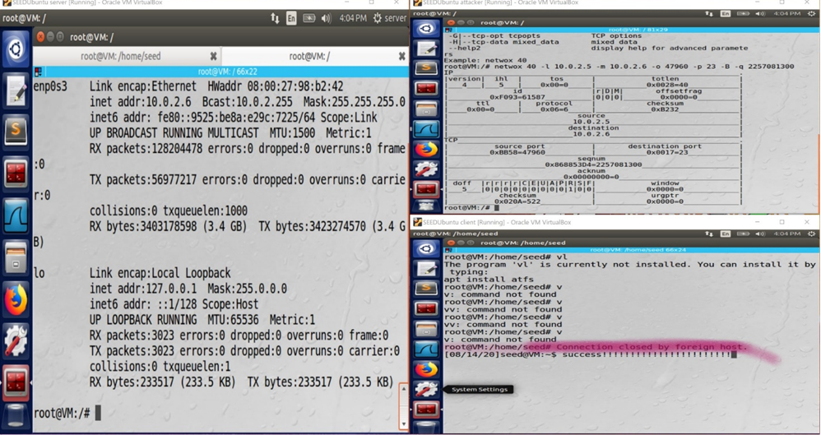The attack is performed successfully.

**ATTACKER**

**CLIENT**

**SERVER**

*Performing the attack over SSH, using scapy:

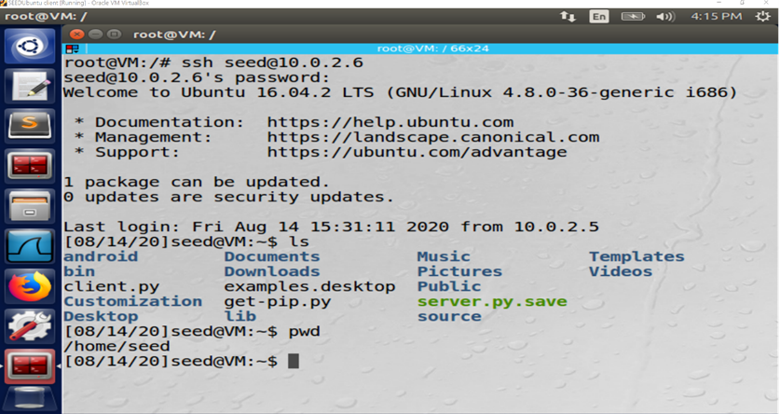The client connects to the server through SSH, and uses the connection.

**CLIENT**

The attacker sniffs the transportation between the targets.

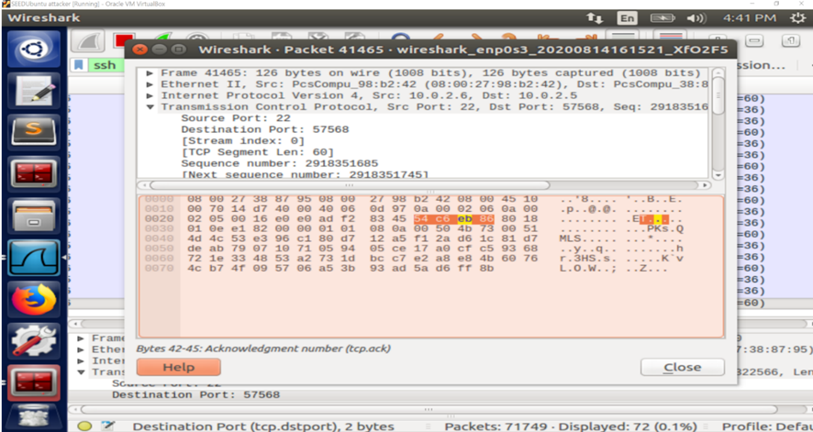The last packet(so far) in the communication:

**ATTACKER**

Writing some script with scapy, in order to spoof packets and send multiple packets which are differed in their sequence number. Using the last sequence number as an initial value to the. We are jumping each time at 60 in order to keep in the pace of the 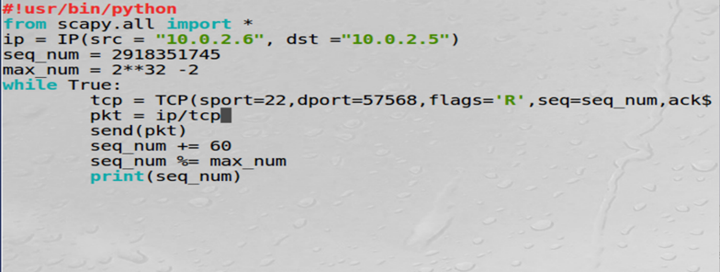connection.

**ATTACKER**

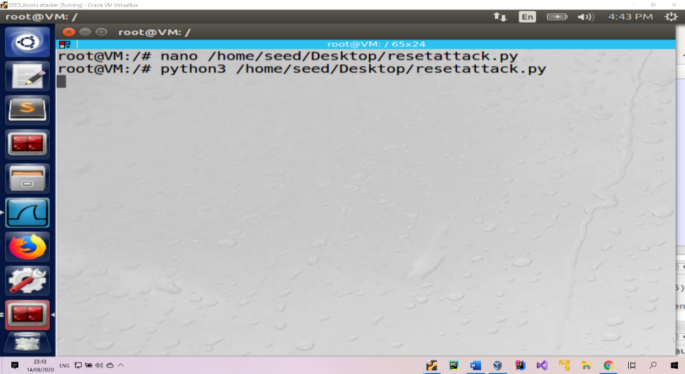The attacker runs his script:

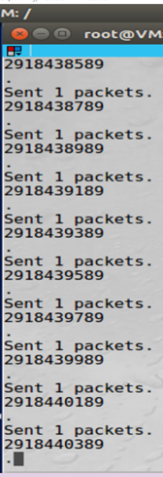How does it look like from the attacker view?

**ATTACKER**

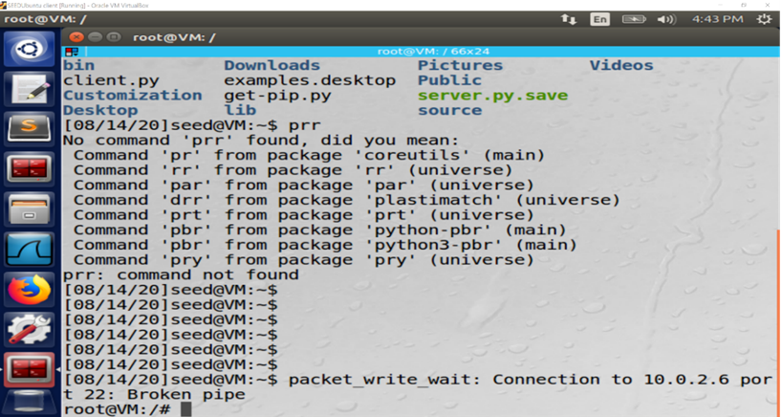

**CLIENT**

The Attack has performed successfully:

2.c) I have succeeded the task. As a proof for that, we can see that the connection has been broken and the server proceeded to work as it was. I have discovered that it is easy to break a connection between two end-points and to do this, one suitable packet is enough. It is easy to spoof packets! I have learned to work with WireShark (to see the transportation in my LAN), scapy and netwox (to spoof packets), SSH and TELNET. This task has performed as I have expected. Because I knew(theory) that if could send RESET packet to the server it would close the connection. The problem which I handled was to send multiple packets with different sequence numbers. First I have tried to use netwox but I failed, then I tried it with scapy and it went as I wished

***)TCP session and session hijacking3***

3.a) In this task, I am going to hijack a TCP connection. In the previous tasks the TCP packets have not payloads, this time it has. I am going to spoof a packet between two end points, the packet contains malicious command which stands for stealing a file content in the server side. First, I will open a listening connection with netcat on port 9998 then sniff the connection details of the targets, then spoof packet of this connection (guessing smartly the sequence number) and after all running this script to cause the server to send to my IP the content of the file – secret. Finally, the content will be sent to me be sent to the listening port 9998.

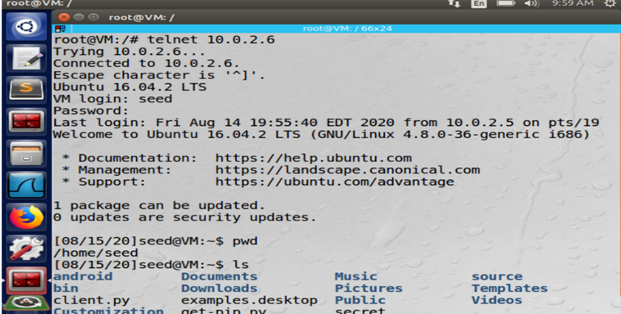3.b)The client connects to the server over TELNET:

**CLIENT**

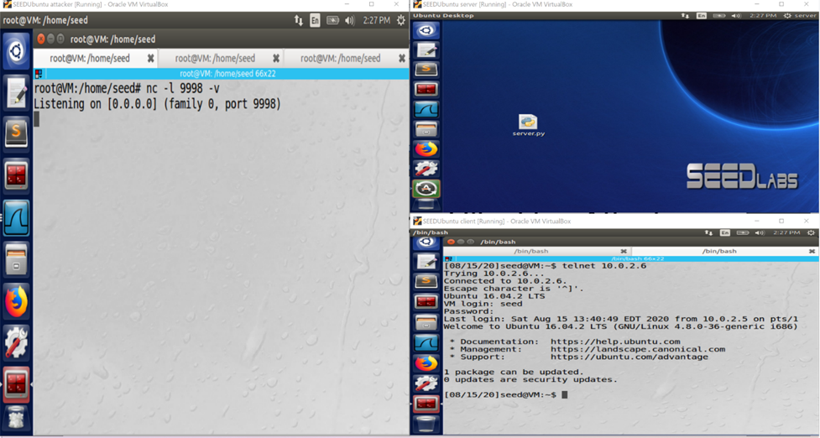The attacker opens a listening connection on port 9998 (netcat):

**SERVER**

**CLIENT**

**ATTACKER**

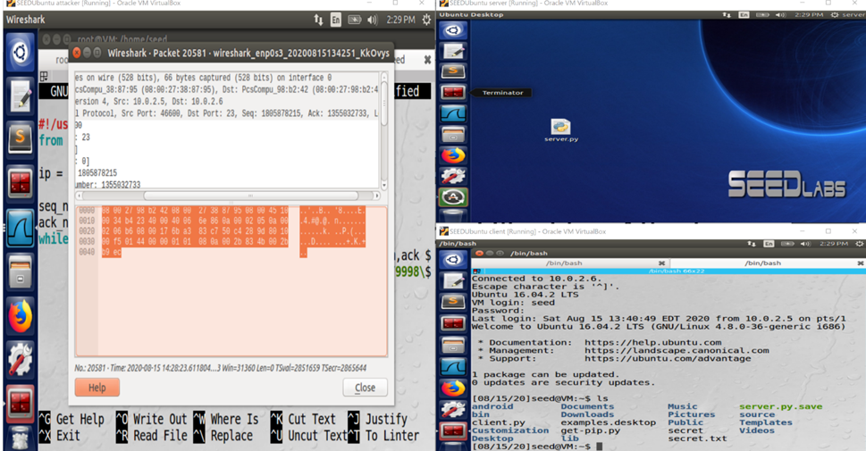The attacker enters to WireShark and sniffs the last packet of the connection between the targets

**SERVER**

**CLIENT**

**ATTACKER**

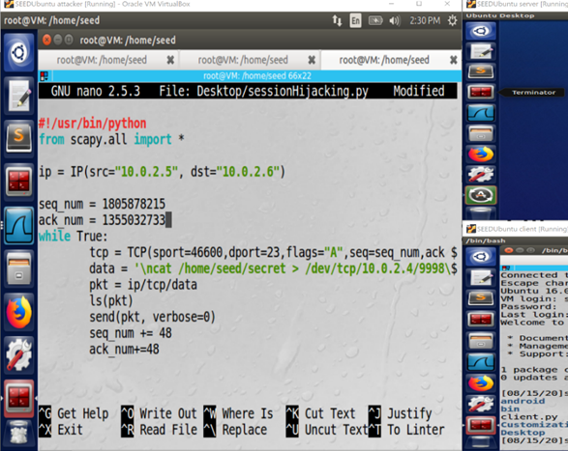The attacker writes a script with scapy to send multiple packets (based on the sniffed packet)

**ATTACKER**

The attacker runs its script

The attack has performed as we have expected!

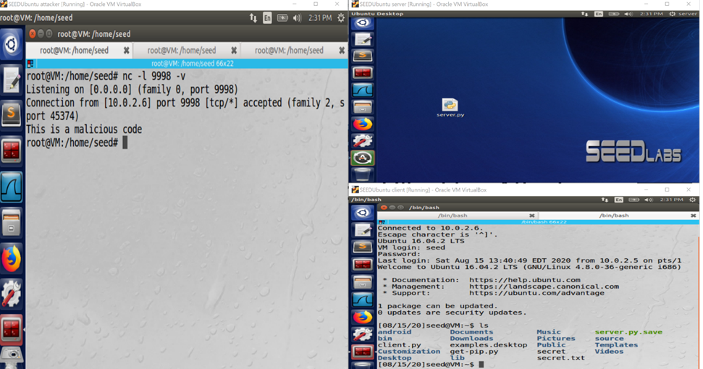

**CLIENT**

**ATTACKER**

**SERVER**

3.c) I have succeed the task. As a proof to my claim, you can see that the content of the file is redirected to the attacker machine. I have discovered that when I use a connection based TCP, someone else can hijack my connection and use my privileges on the server machine which I established the connection with it. I have learned to use netcat to receive connections. Moreover, I learned to run commands on foreign connection and to wrap the command with \n ….\n so that the command would not be concatenated with other command. This is very cool attack, cause we steal the content of very important file in the server! In theory, I thought it is impossible to run malicious commands on foreign connection. But combining my knowledge of spoofing packets really make it easier. My problem occurred when trying to use netwox, I have no idea why it did not work for me. More problem I came across is the size of window that I need to figure wen spoof the packet, at the beginning I did not give a value to the window, then didn't realize why the attack does not succeed so I see in WireShark that my packet has ZEROWINDOW and I fixed the packet with the window size of 2000. When I got really depressed I decided to use scapy and I succeed straight away.

***4)Reverse Shell using TCP Session Hijacking***

4.a) This time, I am going to upgrade the last attack and to run a malicious script which let me to run many commands on the server. This time sending in the payload another command which will connect back to the attacker machine and then. All the steps are the same as the previous task, just changing the payload.



4.b)The client establishes a TELNET connection with the server,

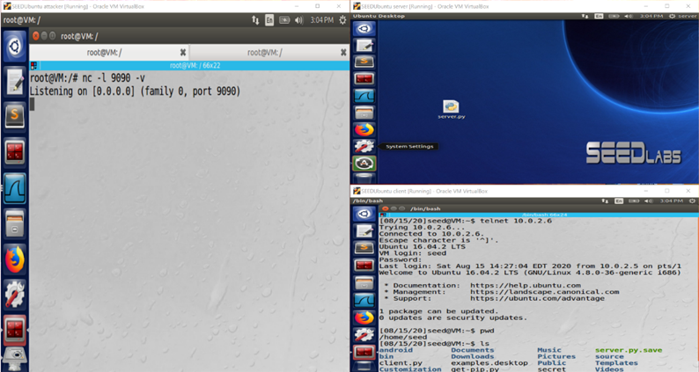The attacker listens on port 9090 using netcat.

**CLIENT**

**ATTACKER**

**SERVER**

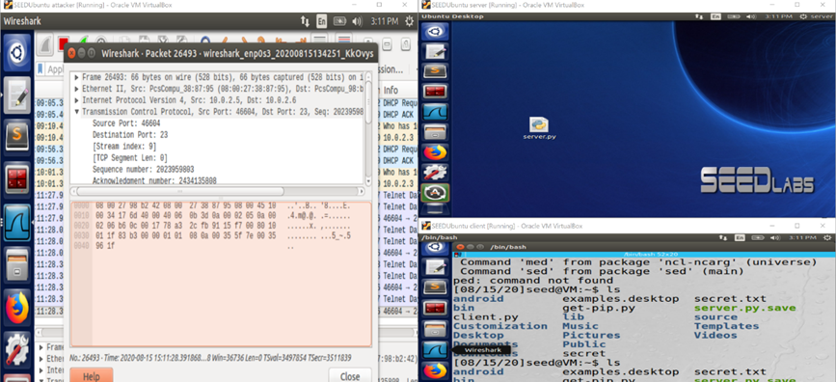The attacker sniffs the last packet in the desired connection:

**CLIENT**

**ATTACKER**

**SERVER**

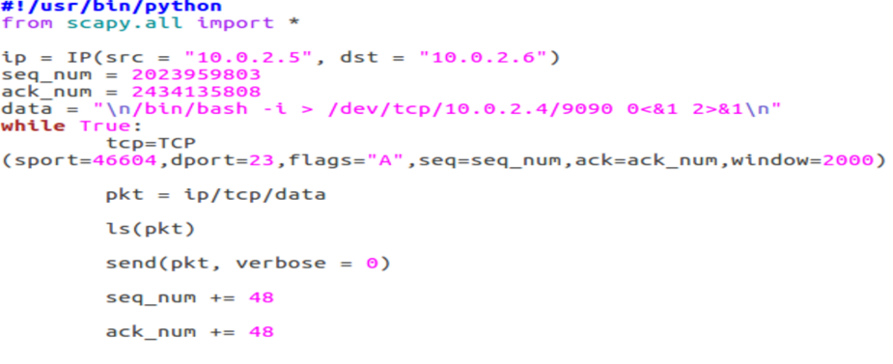The attacker writes short script with scapy, to hijack the session and inject its command to get a shell on the server, he uses the data about the sniffed packet.

**ATTACKER**

The attacker runs the script and the attacker got the shell of the server!!!!

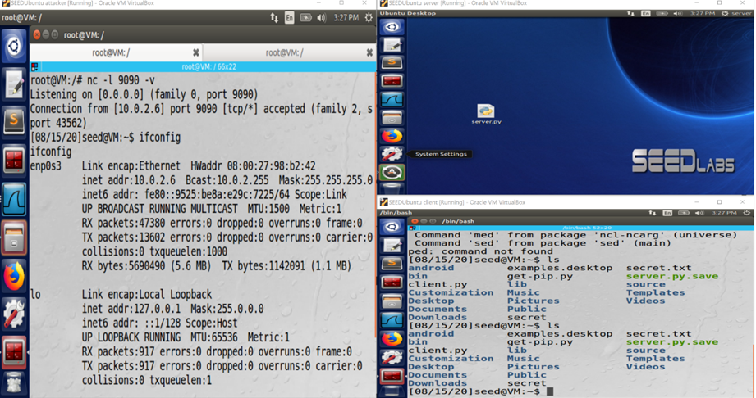Pay attention to the IP address of the shell.

**CLIENT**

**ATTACKER**

**SERVER**

4.c) I have succeed the task. As a proof for my claim, you can see that when the attacker types "ifconfig" he get the IP of the server – 10.0.2.6. I have discovered that an attacker can run any command on some TCP connection(depending in the privileges the client has on the server) and this time the attacker not only hijacked the connection, he produed more damage with creating a backdoor from the server to him. I have learned to get a shell on end – points which communicate over TCP. It does suitable to my theory cause I expected to control on other machine with hijack some TCP connection, and what I did in the attack is exactly that.

***Conclusion:***

To sum up, I have learned a lot during those tasks. I have enriched my horizons as well as enriched my toolkit. I acquired experience in WireShark, scapy, netwox, netcat, reverse shells and more. I also learned that TCP has a lot of security weaknesses. TCP shows us an example of such a design, but there are many other network protocols that have the same problems because of the lack of security.

My lesson from this task, is when designing a protocol, security must be considered during the design and not after is has already designed.

The next lesson for me, is to learn the weaknesses and the countermeasures of other protocols in the transport and the application layers such as: UDP , FTP, SMTP. And to compare the results with what I learned in this task.